Gondola Run!

You are in a trip to Italy. It’s also your first day exploring the world of Venice and to celebrate you go on a gondola trip. You see a storm brewing and knowing that Venice has terribly hard storms, know you have to get to the house your staying at, and soon!

Scene: Gondolas- You know that if you wait too long, the storm will hit and you will be drenched with water from head to toe.

Jump into the Water- You jump into the water; little did you know that water is seriously contaminated. Not only that but you kind of forgot you don’t know how to swim. By the time you get out the storm has come and you end up getting pneumonia and dying. Main Menu

Run away from Gondola Man- You’re not going to wait for that storm to come to you aren’t you? You run away from the Gondola Man who starts chasing after you. But screw those 80 Euros if you won’t be able to enjoy the entire ride. Right? Well, while you’re running you trip on a stone (darn those Venice paths) and fall into the water. You end up getting pneumonia and die. Main Menu

Take in the View- You didn’t pay 80 Euros for nothing. You take in the view and since the Gondola man is a pro paddler, he gets you back to the pier and tells you to take a shortcut through an alley way.

Scene: Alley Way- You go the alley way and, wow all those paths look the same. You begin to second guess whether or not you know the way…
Go for it- Well this turned out differently than you thought. You came to a foreign country and don’t ask for directions when lost? What could possibly happen? You end up getting pneumonia and die. Main Menu
Panic- Well, who knew running around in circles wouldn’t help? The storm catches up to you. You catch pneumonia and die. Main Menu
Ask for directions- What a simple solution! You ask for directions from a local who doesn’t know English but can understand the address you scribbled down. What luck! They point over to the bridge.

Scene: Bridges- Congratulations! You got to the bridge! But now you realize, you are lost again.

Power Through- You aren’t fazed by the possibility of getting lost and dying!
Get Lost-....Which is good considering that that is exactly what ends up happening. Main Menu
Ask for help- You ask for help and this time, they understand and speak English. Whopee! You get to the place your staying but, uh-oh, the clerk is being a jerk and is making you roll a dice for your key.

Dice Roll- 1,3 (player is given Key 1)
2,4,5,6 (player is given Key 2)

Door- Finally you get to your door, one last step! You’re so close!
Key 1- You put the key in and turn it….IT BREAKS! The storm is here…it’s too late...DARN YOU CLERK YOU JERK!!!
Key 2- You put the key in and turn it….SUCCESS! Congratulations! You get to live another day as you sit in your cozy apartment planning your next day in Italy while simultaneously writing a letter to management about the clerk being a jerk.

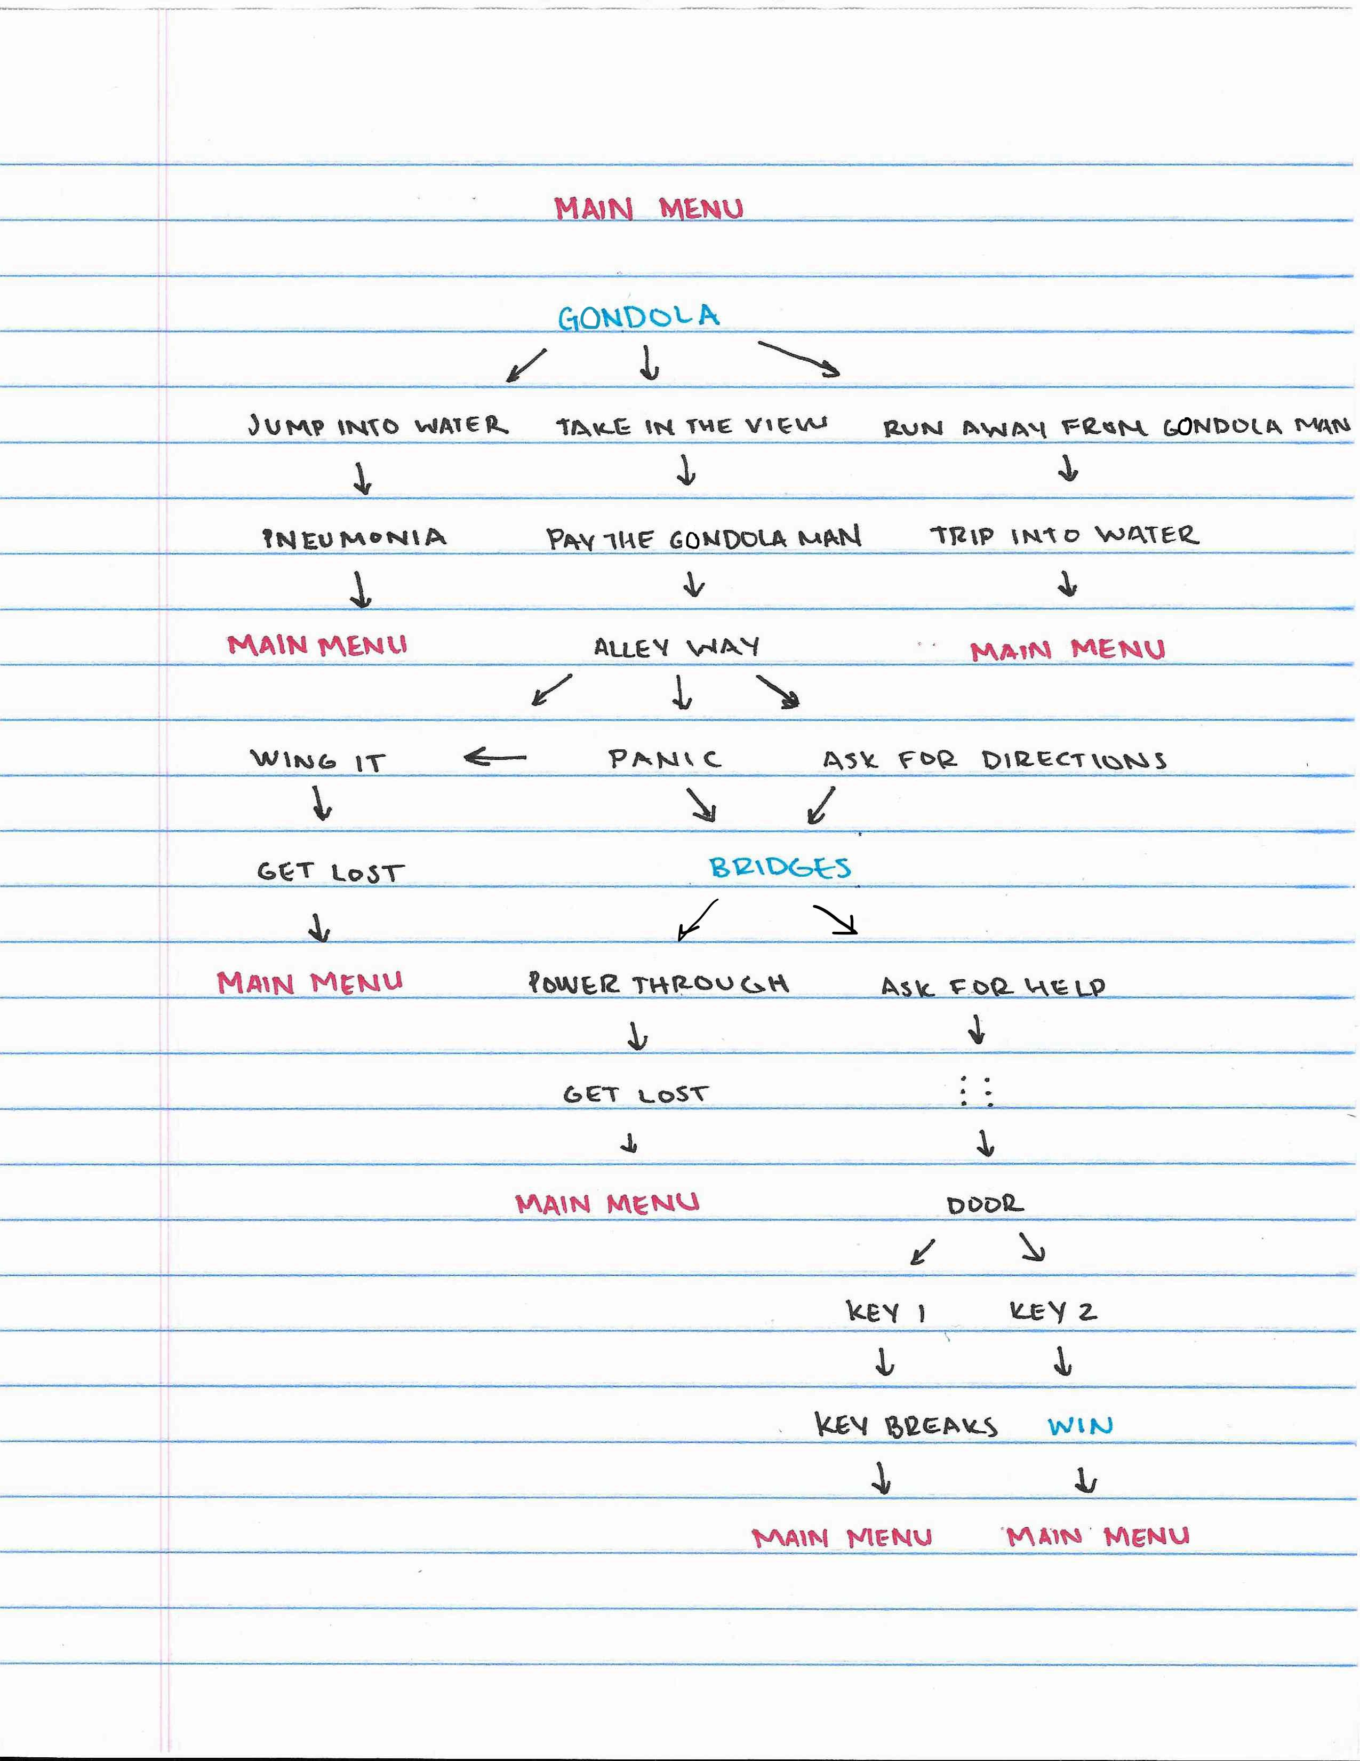

Mock-Up Images: